QML for Hamiltonian Learning and Parameter Estimation

1. Problem
In quantum physics, the Hamiltonian fully characterizes the dynamics of a quantum system. In many practical scenarios (quantum devices, materials, biological systems), the Hamiltonian parameters are unknown and must be inferred from experimental data.
Hamiltonian learning and parameter estimation aim to identify these unknown parameters efficiently from measurement outcomes. Classical approaches scale poorly with system size, motivating Quantum Machine Learning (QML)-based solutions.

2. Intuition
The core idea is:
- The system evolves according to an unknown Hamiltonian
- Measurements contain information about Hamiltonian parameters
- A parameterized quantum model simulates candidate Hamiltonians
- Learning algorithms update parameters to minimize mismatch with observed data
QML avoids full tomography and learns parameters directly from quantum dynamics.

3. Algorithm / Circuit Structure
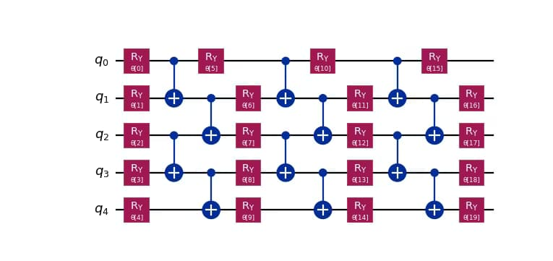
A typical QML-based Hamiltonian learning loop:
- State Preparation
Prepare an initial probe state |ψ₀⟩.
- Parameterized Hamiltonian Evolution
Apply time evolution U(θ) = exp(-iH(θ)t).
- Measurement
Measure observables sensitive to Hamiltonian parameters.
- Cost Evaluation
Compare measured statistics with experimental data.
- Parameter Update
Classical optimizer updates θ.

4. Simple Math Involved
- Hamiltonian model: [ H() = _k _k H_k ]
- Time evolution: [ U() = e^{-i H() t} ]
- Loss function: [ L() = j |O_j {} - O_j _{}|^2 ]

5. Python Code (Hamiltonian Learning – Qiskit)
Platform-agnostic algorithm execution code (educational)
import numpy as np
from qiskit import QuantumCircuit
from qiskit.primitives import Estimator
qc = QuantumCircuit(1)
theta = np.random.rand()
qc.rz(2 * theta, 0)
estimator = Estimator()
observable = [["Z", 1.0]]
value = estimator.run(qc, observable).result().values[0]
print("Estimated expectation value:", value)

6. Where the Algorithm Is Useful
- Quantum device characterization
- Noise and drift estimation
- Quantum sensing and metrology
- Learning effective models of quantum systems

7. Limitations
- Noise limits estimation accuracy
- Requires repeated experiments
- Optimization can be costly
- Scaling to large systems is challenging

8. Comparison with Classical Parameter Estimation
- Data usage: Full tomography vs targeted measurements
- Scalability: Classical exponential vs quantum polynomial (ideal)
- Flexibility: Fixed models vs learnable Hamiltonians
- Maturity: Classical methods mature; QML methods emerging

9. One-Sentence Summary
QML for Hamiltonian learning estimates unknown quantum dynamics by training parameterized quantum models directly from measurement data.

